**Asset Brief Absolut Gen AI**

Table of Contents

Scope 1

Phases 1

Timings 2

Asset 001 details – Always on 2

Asset 002 details - Occasion 2

Guidelines and References 3

# Scope

Evaluate Gen AI KDP tool capabilities in generating in-situ imagery, which can be used in channels such as e-Commerce.

Determine how consumers react to Gen AI content using AskNow, and potentially in an extension evaluate performance in market.

# Phases

1. Generate 1 Always-on image and 1 Occasion image (see details in next chapter) (HQ)
2. Post production (TAG+HQ)
3. Test with AskNow (TAG)
4. Add assets in market for future test (TAG+HQ)
   1. Meta Paid activation
   2. Within e-Retailer context (TBD)
5. Evaluation
6. Future Absolut Hunni e-Com content

# Timings

* AskNow testing end of January
* In market test H1 February (pending market availability)
* Future Absolut Hunni e-Com Content – TBD

# Channels, Formats & Outputs

**Channels:**

Meta paid activation  
Amazon A/B Testing on PDP

**Formats:**  
1:1(2160x2160 px) 9:16 (2160x3840 px), 16:9 (2400x1260 px), 4:5 (2160x3840 px)

**Outputs:**

4 Asset files (Asset 001 – Always on)  
4 Asset files (Asset 002 – Occasion)

Total 8 Asset files

JPG  
Max file size 30 mb

# Asset 001 details – Always on

**Objective:**  
Develop an engaging e-commerce asset to promote a fun, energetic celebration at home or outdoors, such as a BBQ or casual gathering. The focus is on creating a playful and youthful vibe that resonates with a broader audience—friends, families, and groups enjoying a longer weekend together.

**Key Focus:**  
The asset should highlight a variety of cocktails (at least 3), emphasizing versatility and the social energy of larger gatherings. The tone and visuals should inspire customers to celebrate moments of connection, fun, and spontaneity in a relaxed, upbeat environment.

**Audience:**  
A diverse, broad group looking to create lively and playful experiences with friends and family. The energy is lighthearted, dynamic, and inclusive—far removed from the intimacy of Valentine's Day.

**Execution:**

* Feature vibrant visuals of mixed serves, bottles, and cocktails being enjoyed in a lively home or outdoor setting.
* Showcase group celebrations—BBQ, or casual get-togethers—that feel authentic and full of energy.
* Drive conversion by inspiring customers with easy, fun drink ideas perfect for larger groups.
* Space for shorter “Born to Mix” text (see references below).

# Asset 002 details - Occasion

**Objective:**  
Develop an appealing e-commerce asset to promote Valentine day serves.

**Key Focus:**

The asset should capture Valentines Day and subsequent related cocktails, for example Espresso martini or Bay Breeze. The asset should feature cocktails and bottle to drive conversion among customers looking for Valentine’s Day celebration ideas.

**Audience:**Couples celebrating Valentine’s Day, Valentines Day Party Planners and Cocktail enthusiasts.

**Execution:**

* Colors and light more gold, pink, red with candle light features, but still keeping Absolut brand consistency.
* Setting should be Valentine Days Celebration/Party
* Absolut Original bottle in-situ should be included
* Two drinks should be present, e.g Espresso Martinis
* Image should have a mixing feel to it, barware in the background etc.
* Recipe space to the right or left (see references)

Guidelines and References

Refer to [Absolut MBI Document (BrandCloud)](https://brandcloud.pernod-ricard.com/media/?mediaId=77CF2396-C93E-44D9-A9670E3817F572B5) for general brand MBI.

**Pay Special attention to the following:**

Photography guidelines (see Absolut MBI page 88-89 for more info)

1. We are bold, witty and creative.
2. We are inclusive, entertaining and human.
3. We use bold, powerful and strong colours.
4. We are in the middle of the moment, not bystanding watching.
5. We are in the party, not looking in. No poses, always real.
6. We celebrate diverse groups of amazing people.
7. We are fun, cheeky playful, and optimistic. Never too heavy or serious.
8. We always have the bottle and the drinks present in the image .
9. The bottle and cocktails are always our focal point.

**Photographic references from the Absolut MBI**

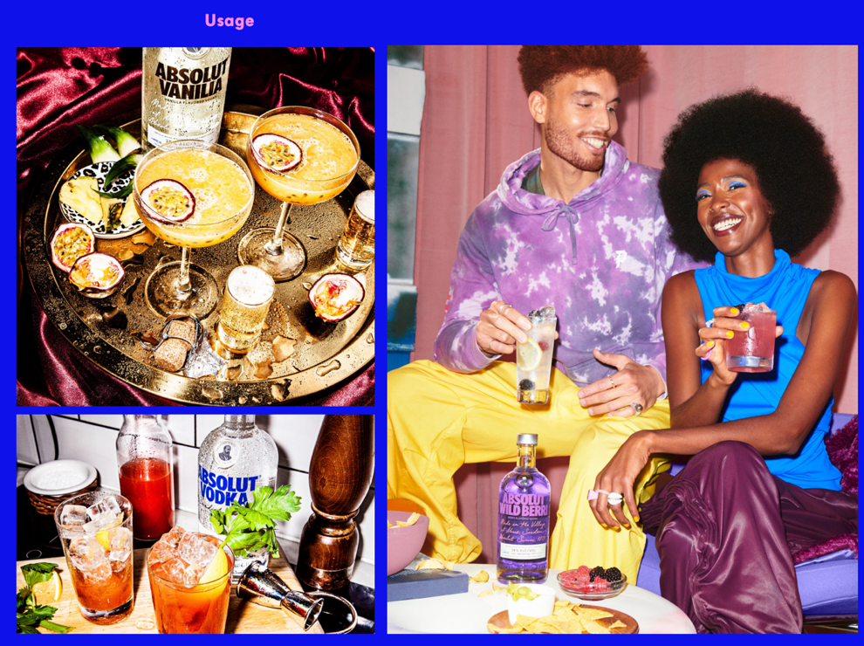

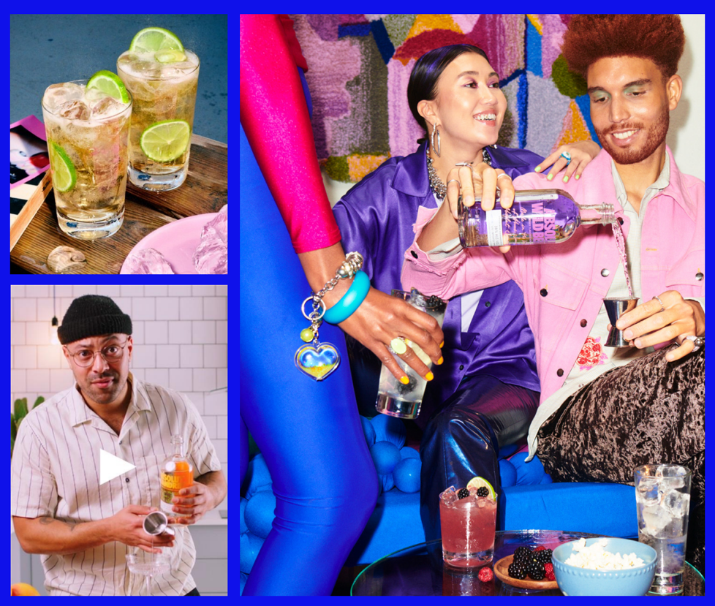

**Seasonal Recipe Cards**

|  |  |
| --- | --- |
|  |  |
| **Always on Assets Absolut Vodka** |  |
|  |  |

**Always on Assets Absolut Hunni**  
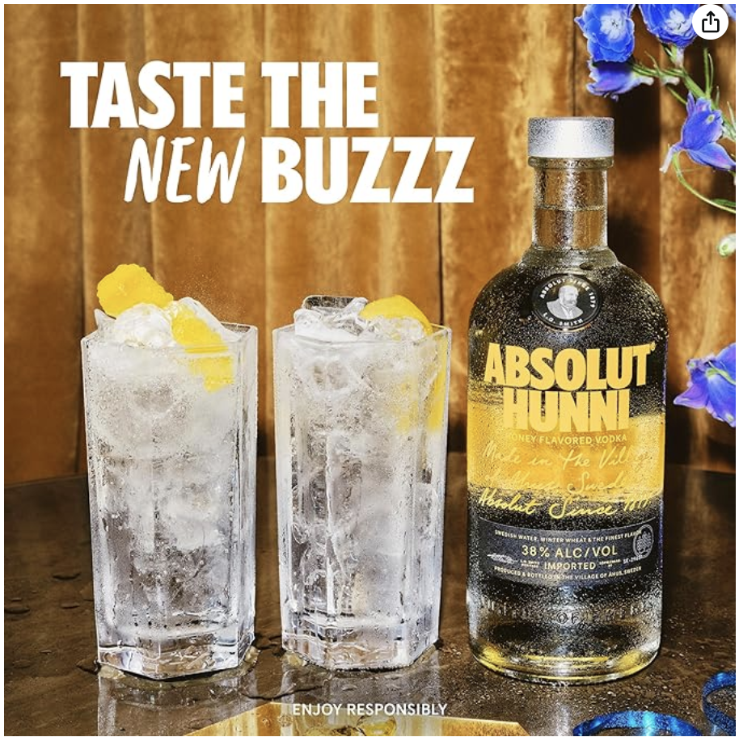 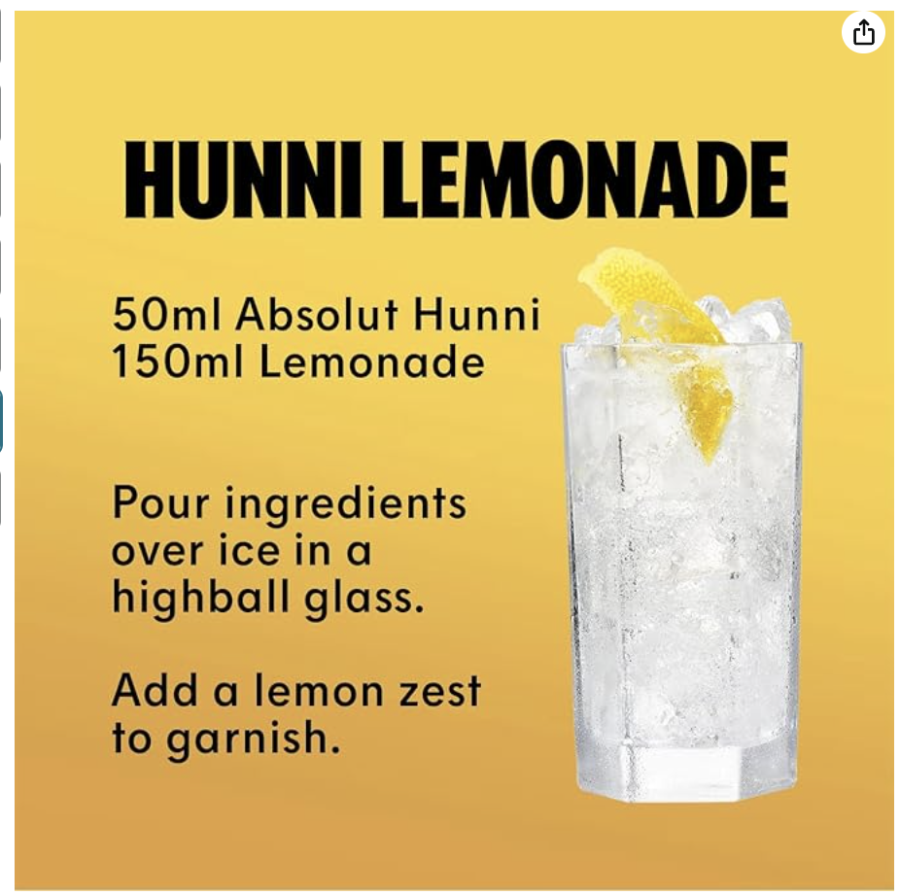

**Banners Previous Meta Activations**

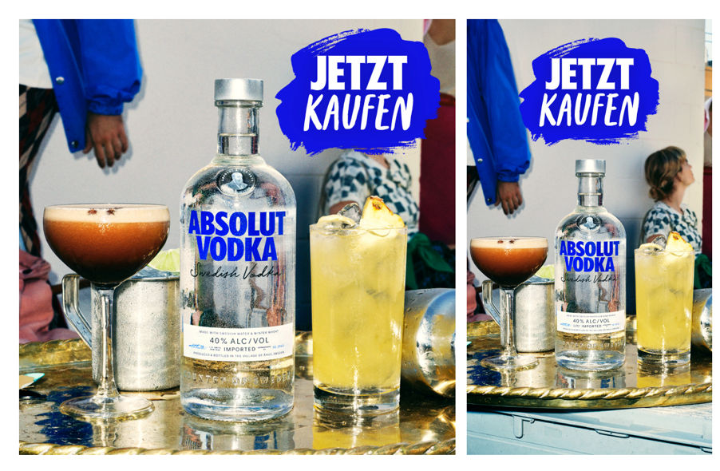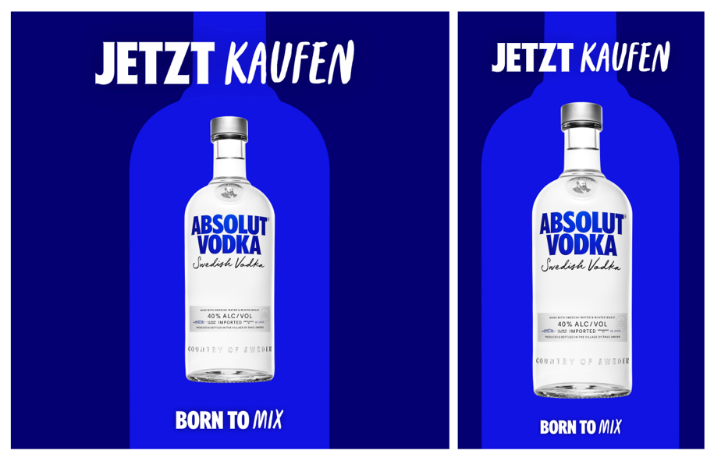

**Banners e-Retail Media**

